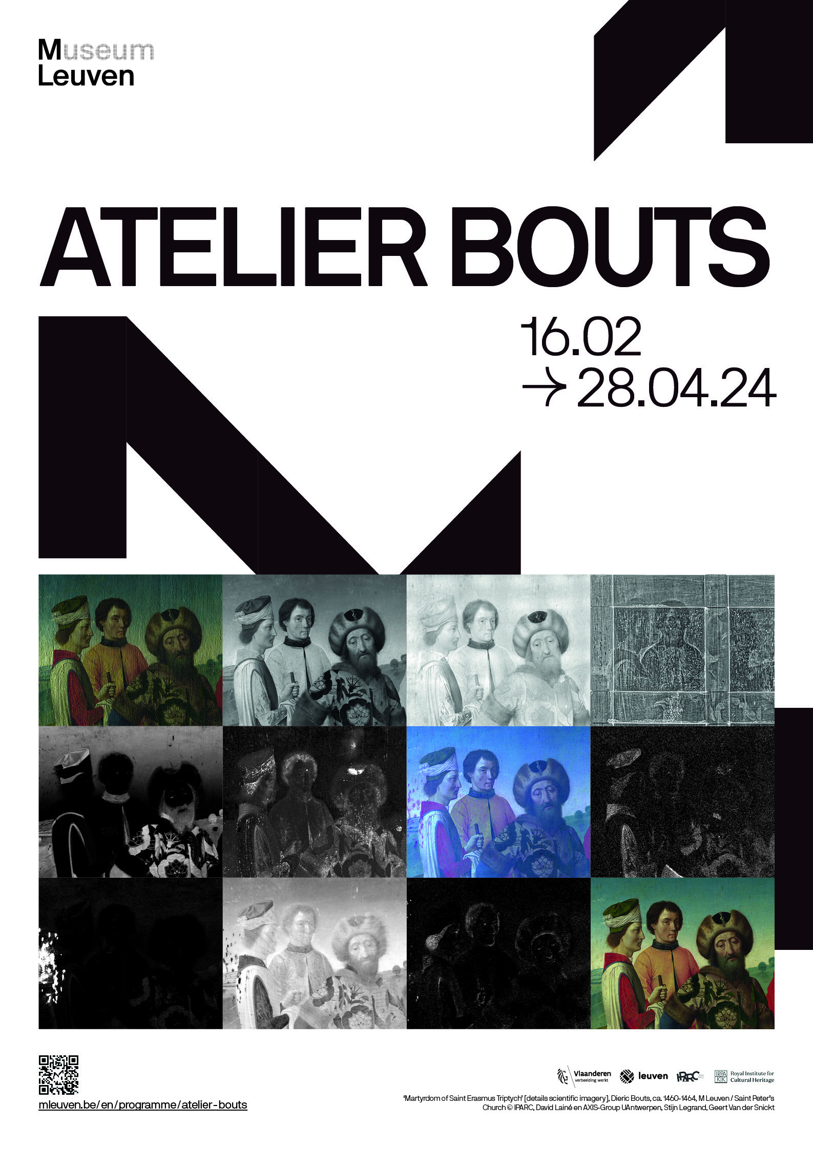

**IN THIS PRESS KIT**

Atelier Bouts 3

Six works, six technologies 4

Food for Thought 16

Practical info 17

Contact 18

**M LEUVEN PRESENTS FOCUS EXHIBITION ‘ATELIER BOUTS’’**

**‘Atelier Bouts’ lays bare the master’s practice and showcases the latest research and restoration project**

**16.02-28.04.2024**

‘Atelier Bouts’, which runs from 16.02 to 28.04, is a fascinating follow-up story to M Leuven’s international retrospective ‘DIERIC BOUTS. Creator of Images’. Six iconic artworks have been retained by the museum for a focus exhibition on the scientific research into a 15th-century masterpiece. Visitors will discover the techniques of the Flemish Masters, the composition of the various paint layers, whether Bouts was the sole mastermind behind the works attributed to his hand, and how they are restored today – some 500 years later.

“M Leuven is immensely proud of the successful New Horizons |Dieric Bouts Festival, but we are far from saying goodbye to Bouts, on the contrary,” says Bert Cornillie, Alderman for Culture and Chairman of M’s board of directors. “Now that Bouts is definitively on the map as an important Flemish Master, he will not only continue to be present in St Peter’s Church but also at M. This focus exhibition zooms in on the technical and scientific aspect of his work and takes us behind the scenes of the artist’s studio.”

“A visit to ‘Atelier Bouts’ is an unmissable opportunity to see four of Bouts’s most important triptychs in the same room”, adds Marjan Debaene, curator of Old Masters at M Leuven, “‘The Last Supper’ and ‘The Martyrdom of Saint Erasmus’ will be permanently returned to St Peter’s Church after the exhibition, while ‘The Martyrdom of Saint Hippolytus’ will go back to St Salvator’s Cathedral in Bruges. Meanwhile, ‘The Descent from the Cross’, a prestigious loan from Granada, will travel to the KIK-IRPA for a major restoration campaign. The exhibition takes a closer look at how a restoration is conducted. Visitors will also learn about cutting-edge technologies such as macro-XRF scanning, infrared reflectography and dendrochronology, and the surprising discoveries they have already yielded.”

In collaboration with [**IPARC**](https://www.iparc.eu/nl/) and [**KIK**](https://www.kikirpa.be/nl/)**-IRPA**.

**SIX WORKS, SIX TECHNOLOGIES**

Thanks to modern imaging techniques and innovative material research, ‘Atelier Bouts’ sheds new light on six of the most iconic works created in Dieric and Albrecht Bouts’ studios some 500 years ago.

Like his contemporaries, Bouts worked in layers. The base layer, called the support, is usually a panel of Baltic oak. On top of that comes the preparation layer, typically consisting of an animal glue and chalk mixture. This ensures a flat, smooth surface. On top of that, an underdrawing is applied in black, followed by an isolation layer of lead white pigment in oil. This is followed by the underpainting, which establishes the rough composition in colour. Next multiple layers of glazes in colour are applied, bringing the scenes to life. Finally, the paint layers are protected with a coat of varnish.

For a very long time, art historians could only examine those layers visible to the naked eye. However, thanks to techniques such as infrared reflectography and radiography, it is now possible to meticulously examine and analyze each layer. As such, we can trace the creation of Bouts' works as though we were present during their making. From the very early underdrawing to the finished painting. This provides a wealth of information, and intriguing new insights into the master's methods.

1. CHRIST CROWNED WITH THORNS - RADIOGRAPHY

Workshop of Dieric Bouts, ca. 1470, M Leuven

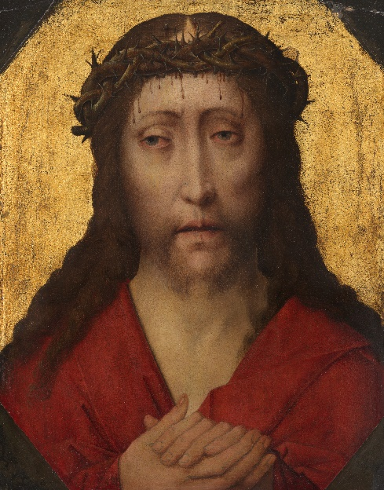

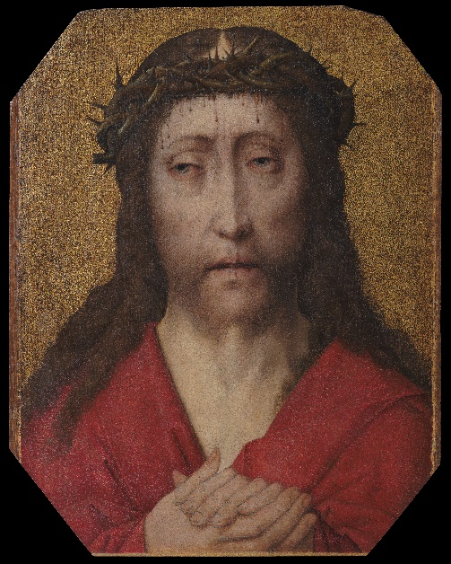

‘Christ Crowned with Thorns’, workshop of Dieric Bouts, ca. 1470, M Leuven © KIK-IRPA, Brussels

‘Christ Crowned with Thorns’ [before restoration], workshop of Dieric Bouts, ca. 1470, M Leuven, photo: artinflanders.be, Cedric Verhelst

‘Christ Crowned with Thorns’ [radiography], workshop of Dieric Bouts, ca. 1470, M Leuven © KIK-IRPA, Brussels

**Radiography** is the technical term for making X-rays. Most of us are acquainted with X-rays, as they are commonly found in our medical records. The technique has been in use for more than a century. A radiologist directs a beam of X-rays toward the body part they wish to visualize. A photographic film is positioned on the other side of your body, serving as the medium that captures the X-ray picture.

Bones are relatively heavy and dense. They therefore stop most of the radiation from reaching the photographic film, leaving it unexposed. On the developed film, these unexposed areas appear bright and translucent. Softer, lighter tissues, such as muscles, are easily passed by the radiation. On the developed film, they appear matte and dark. The degree of darkness thus corresponds to the amount of radiation passing through the tissue - the more radiation reaching the film, the darker it becomes.

Radiography is used in exactly the same way to examine paintings. Lead-based paints or other dense materials block the X-rays, resulting in bright spots on the radiographic image. Lighter materials, such as organic pigments, allow the radiation to pass through, resulting in grey or black tones on the film.

The X-ray you see here was taken when ‘Christ Crowned with Thorns’ was first brought into the restoration studio. The bright white objects visible along the edges are nails with which small, non-original planks were attached to the panel. They were removed as part of the conservation treatment. The two white spots in the centre are the wax seals located on the back of the painting. The X-ray thus allows us to see through the entire panel.

Even though the paint layers are very worn down, allowing a substantial amount of radiation to pass through, we can still infer certain details from the X-ray. The artist started by applying the gold leaf. This partially blocks the X-rays, causing it to light up a little. The area where Christ's head was designed to be depicted was left in reserve, so no gold leaf was applied there. In the 15th century, it was a common artistic technique to intentionally leave areas in reserve.

For the head itself, the artist applied an underpainting in lead white. This underpainting blocks a significant amount of radiation, resulting in it being slightly brighter on the X-ray. The hair is painted with very thin layers. These are easily penetrable for X-rays, making Christ’s hair dark on the X-ray. The white specks on the crown of thorns are highlights applied in lead white.

1. MATER DOLOROSA - DENDROCHRONOLOGY

Albrecht Bouts, after 1490, private collection Luxembourg

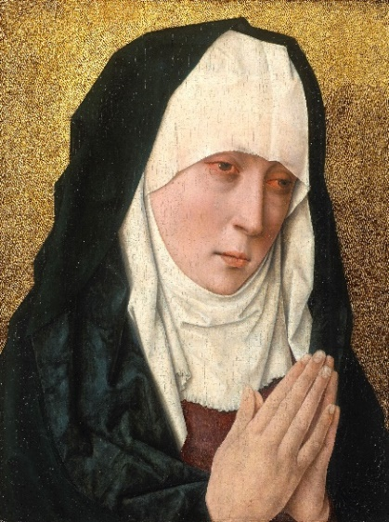

‘Mater Dolorosa’, Albrecht Bouts, after 1490, private collection Luxembourg © KIK-IRPA, Brussels

Panels like this ‘Mater Dolorosa’ and ‘Christ Crowned with Thorns’ were highly popular in the 15th and 16th centuries. Believers would display these artworks in their homes and use them for private devotional practices. Dieric Bouts painted quite a few of them. His son, Albrecht, likewise continued this tradition. So the question at hand is: who painted these panels, Dieric or Albrecht?

To address this question, we can turn to **dendrochronology**, the scientific discipline dedicated to dating wood samples. To achieve this, it measures the growth rings of trees.

The thickness of growth rings varies. During cool, dry summers, trees experience limited growth, resulting in narrow growth rings. Warm and humid summers on the other hand lead to the formation of wider growth rings. The sequence of growth rings can be represented in a graph that scientists call a dendrochronological series.

In these kinds of graphs, peaks represent favourable growth years, whilst low points indicate years of limited growth. Dendrochronological sequences of trees from the same region and time period have a significant resemblance to each other.

Both father and son Bouts painted on panels made from oak trees sourced from the Baltic Sea region. The dendrochronological series of these panels can be compared to reference chronologies of the Baltic region. This analysis allows us to determine the period when the oak tree that provided the panels was growing and to identify the year corresponding to the youngest visible growth ring.

The results are enlightening: the youngest growth ring can be dated back to the year 1481. As Dieric Bouts passed away in 1475, it is impossible for him to have painted this ‘Mater Dolorosa’. Instead, it originates from the workshop of his son, Albrecht.

For ‘Christ Crowned with Thorns’, the results of the dendrochronological study cannot definitively answer whether this painting was made in Dieric or Albrecht Bouts’ workshop. It can only be determined that the tree was felled sometime after the year 1417.

1. TRIPTYCH OF THE DESCENT FROM THE CROSS –

MACRO PHOTOGRAPHY

Dieric Bouts, ca. 1455, Cabildo de la Capilla Real de Granada

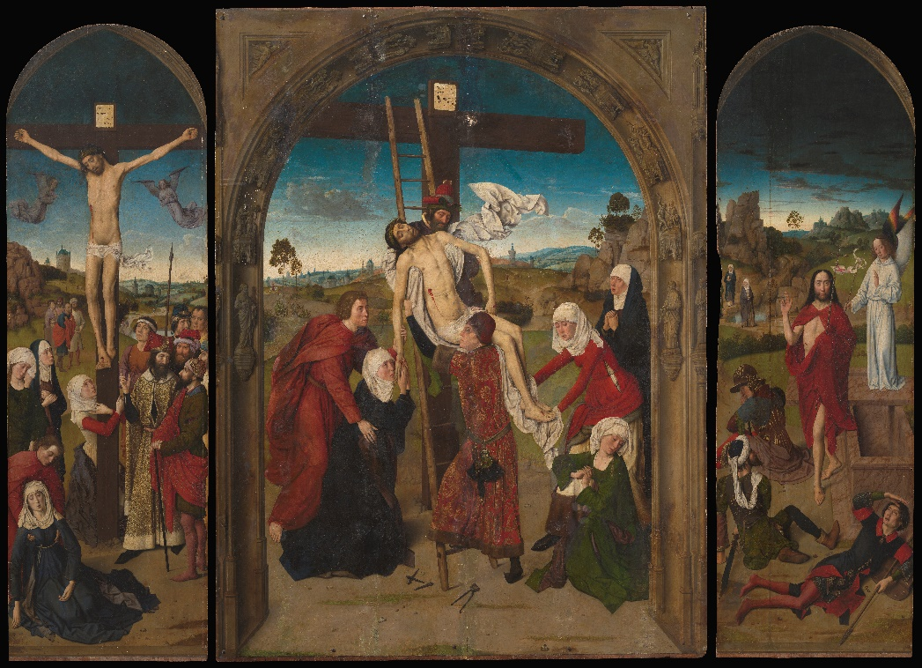

‘Triptych of the Descent from the Cross’, Dieric Bouts, ca. 1455, Cabildo de la Capilla Real de Granada © KIK-IRPA, Brussels

The 'Triptych of the Descent from the Cross' is one of the largest works by Dieric Bouts.

The analysis of a painting of this nature starts with a regular visual inspection, with the naked eye or a magnifying glass. To do this, unlimited access to the artwork is, of course, required. In practice, only a select few individuals have this opportunity to intensively study the painting up close. Fortunately, **macro photography** provides a more accessible solution. Using a hundred-megapixel camera, we can capture highly detailed images of the artwork. These are stitched together to create an ultra-high-resolution mosaic image. This allows one to zoom in on the tiniest of details.

The combination of naked eye observation and macro photography has provided many new insights into the 'Triptych of the Descent from the Cross’. These insights will prove invaluable during the restoration process. That is the task that the Royal Institute for Cultural Heritage will undertake following this exhibition.

Especially the central panel is in poor condition. There are many lacunae - areas where the original paint has disappeared. Subsequent restorers have covered these areas with paint, but in some instances, they seem to have also overpainted the original paint layers. Also, the paint they used ages differently compared to Bouts' original paint. This is clearly visible, for example, in the stone arch on the central panel: the brown blots were once the same colour as the original paint layer.

These later added layers of paint will be removed, fully uncovering Bouts' original paint layer. The lacunae will be retouched, this time using reversible paint that can be easily removed in the future.

The side panels are in better condition than the central panel, yet they too require restoration - especially to remove the yellowed, non-original layers of varnish. The dirt it accumulated over the years, causes Bouts' colours to appear dull and brownish. The final step in the restoration process is the application of a new coat of varnish. This will protect the painting from dirt for the near future, and can easily be removed when needed. The new varnish will also restore the colours' shine.

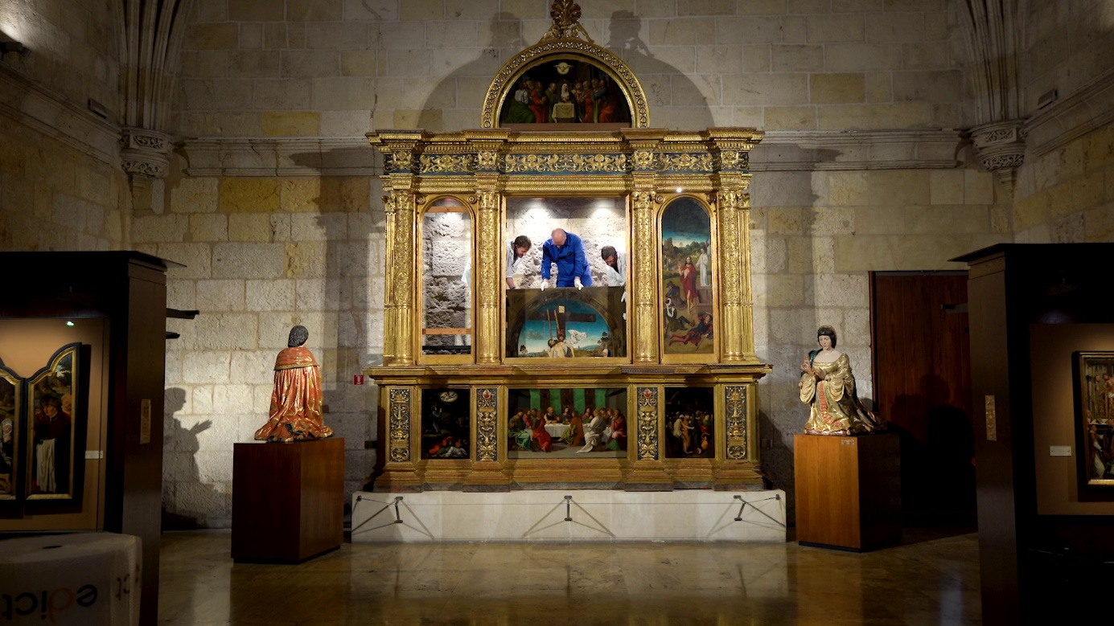

The ‘Triptych of the Descent from the Cross’ is taken out of its frame at the Capilla Real in Granada © Het Beweegt and M Leuven

1. MARTYRDOM OF SAINT ERASMUS TRIPTYCH –

MACRO-XRF-SCANNING

Dieric Bouts, ca. 1460-1464, M Leuven / Saint Peter’s Church

‘Martyrdom of Saint Erasmus Triptych’ [macro-XRF, iron], Dieric Bouts, ca. 1460-1464, M Leuven / Saint Peter’s Church © AXIS-Group UAntwerpen, Stijn Legrand, Geert Van der Snickt

The 'Martyrdom of Saint Erasmus Triptych' was restored in 2019. Today, the restoration of such a precious work is almost unthinkable without thorough preparatory research. Scientists have employed a wide range of techniques for this purpose. These include a relatively new imaging method: **macro-X-ray fluorescence scanning**, abbreviated as MA XRF Scanning.

Macro XRF examines an object by firing powerful X-rays at it. That object - like everything else in the universe - is composed of chemical elements: iron, mercury, potassium, titanium, or other old acquaintances from the periodic table. In reaction to these X-rays, these elements subsequently start to emit X-rays themselves. The wavelength of the emitted X-rays is specific to each element. As such, by capturing and measuring this radiation, we can identify which elements are present within the object and where they are located.

Macro XRF generates a distribution map of each element. This map represents the distribution of the specific element across the painting in black and white. The darker a particular point, the lower the concentration of the element, and the lighter the point, the higher the concentration.

With Macro XRF we can date paintings and obtain invaluable insights into the artist's techniques and materials. It can also assist in uncovering hidden layers or detecting alterations. For instance, it can reveal if an artist painted over an existing image or modified their composition. With Macro XRF we can also identify non-original paint layers. Elements such as titanium, zinc, barium, and chromium were not present in pigments during Bouts' era. When we find these elements, they can indicate overpaintings by a 19th or 20th-century restorer.

‘Martyrdom of Saint Erasmus Triptych’, Dieric Bouts, ca. 1460-1464, M Leuven / Saint Peter’s Church, photo: artinflanders.be, Dominique Provost

1. TRIPTYCH WITH MARTYRDOM OF SAINT HIPPOLYTUS –

INFRARED REFLECTOGRAPHY

Dieric Bouts and workshop & Hugo van der Goes, ca. 1475 (centre panel and right wing) and ca. 1479 (left wing), Treasury St. Salvator’s Cathedral, Bruges

‘Triptych with Matyrdom of Saint Hippolytus’, Dieric Bouts and workshop & Hugo van der Goes, ca. 1475 (centre panel and right wing) and ca. 1479 (left wing), Treasury St. Salvator’s Cathedral, Bruges, photo: artinflanders.be, Hugo Maertens

The 'Triptych with Martyrdom of Saint Hippolytus' is one of Bouts' last paintings. He died before he could finish it. Based on stylistic analysis, there is a hypothesis that the left panel, featuring the patrons' portraits, may have been painted by Hugo van der Goes. This hypothesis is reinforced by research conducted using infrared reflectography, abbreviated as IRR. Yet, what is IRR exactly, and what insights can it provide?

We are continuously surrounded by electric and magnetic waves, collectively referred to as electromagnetic radiation. We are quite familiar with some of it: we perceive the waves ranging from 380 to 750 nanometres in length as visible light. Wavelengths ranging from 750 to 300,000 nanometres are classified as infrared. Although we cannot see them directly, we can convert them into the visible spectrum using special cameras.

Infrared reflectography or IRR employs a specific spectrum of infrared waves, typically ranging from 950 to approximately 1700 nanometres. These waves penetrate the paint layers. To an IRR camera, the paint layer is as transparent as the varnish layer is to the human eye.

Below the paint layer lies the underdrawing. This initial outline of the composition is typically executed with charcoal, black chalk, or ink. These materials contain carbon, which absorbs infrared rays, whilst the white preparation layer reflects the rays. Due to these characteristics, images made with IRR can make the underdrawing visible.

The underdrawing gives us invaluable insights. Frequently, the underdrawing is created by the master artist himself. As part of the design process, an artist makes compositional changes. These alterations offer us a glimpse into their quest for the ideal composition. The underdrawing thus provides insight into the painter's creative process even before he starts painting.

In the case of the 'Triptych with Martyrdom of Saint Hippolytus’, this underdrawing has been hidden under the paint layer for 500 years. Thanks to IRR, we can once again see the underdrawing. This furthers our understanding of the creative process.

‘Triptych with Matyrdom of Saint Hippolytus’ [infrared reflectography, left wing], Dieric Bouts and workshop & Hugo van der Goes, ca. 1479, Treasury St. Salvator’s Cathedral, Bruges © KIK-IRPA, Brussels

1. LAST SUPPER TRIPTYCH - STRATIGRAPHY

Dieric Bouts, 1464-1468, M Leuven / Saint Peter’s Church

‘Last Supper Triptych’, Dieric Bouts, 1464-1468, M Leuven / Saint Peter’s Church, photo: artinflanders.be, Dominique Provost

In this display, we can see three paint samples taken from the central panel of the ‘Last Supper Triptych’. They show us the glazing technique that was essential to Bouts and other Flemish Primitives.

This particular technique involves applying multiple semi-transparent layers of paint on top of each other. These layers are called 'glazes'. A glaze consists of a relatively large amount of oil with a little bit of pigment. Each glaze has a slightly different composition. As light passes through the various layers, vibrant colours, deep shadows, and seamless transitions — characteristic features of the Flemish Primitives – are created.

In Bouts' workshop, his assistants would craft the paints themselves by rubbing pigment into oil. Each layer of paint had to dry for several days. So Bouts had to carefully plan the desired end result before putting down the first brushstroke.

We can find out how Bouts' applied his paints and their composition by studying paint samples. A scalpel is used to extract a miniscule paint sample, which is then cast in resin. This creates a cross-section in which the different layers are clearly discernible.

When paint samples are taken, no matter how small, a piece of the painting is removed. Therefore, it is justified only when other research techniques fall short. Samples are taken from the edge of the painting or in a lacuna in the paint layer. Furthermore, they are not discarded but remain available for further study and new research methods.

The paint samples of the blue and green cloak, for example, were taken more than 70 years ago. At the time, they were studied under a microscope. This led to tentative conclusions about the materials used, which were written down. Today, chemists can identify pigments and binders with great certainty.

On two of the three samples we see a thick white layer of lead white on the bottom, dating back to the 19th century. At the time, a restorer performed a very invasive procedure, called a 'transposition'. This involves removing the paint layer from the original panel and transferring it onto a new support.

To remove the original support, the restorer sanded the panel all the way down to the back of the paint layers. On that back, he applied a thick flattening layer of lead white. He affixed a mesh to the lead white layer, before finally glueing it to a new panel.

### FOOD FOR THOUGHT

‘Food for Thought’ is M’s diverse programme of lectures, classes, debates and encounters. From introductions to expert analyses: there is something for everyone. And it’s all free! M is organising two in-depth ‘Food for Thought’ lectures to coincide with the ‘Atelier Bouts’ exhibition.

**WELCOME TO ‘ATELIER BOUTS’**

**15.02**

**On Bouts as an artist and the material history of selected paintings**

This ‘Food for Thought’ lecture takes a comprehensive look at some of the Flemish master’s most iconic paintings. How did Bouts create his artworks, and was he working alone? From panel, through to primer and underdrawing, right down to the final paint layers: how were these works constructed? And how do conservators study and treat them today? On the opening night of ‘Atelier Bouts’, Marjan Debaene (M Leuven), Bart Fransen (KIK), Valentine Henderiks (Université Libre de Bruxelles/Fondation Périer-D’Ieteren) and David Lainé (IPARC) will delve deeper into Bouts’s masterpieces and explain the master’s techniques.

After the ‘Food for Thought’ lecture, you are welcome to examine the painting up-close during a free visit to the museum. And you can also enjoy a pre- or post-exhibition drink.

[Registration essential](https://www.mleuven.be/programma/mysterieuze-bouts)

**DIERIC BOUTS, A PROMINENT CITY PAINTER AND ENIGMA**

**21.03**

**In search of Bouts**

We know the names of Dieric Bouts’s wives and sons. We know he that he hailed from Haarlem (Netherlands) and became the city painter of Leuven, where he died in 1475. And we have two documented and dated masterpieces by the old master. Altogether, we have more information about Bouts than for the majority of other great 15th-century Netherlandish painters. And yet Bouts and his artistic evolution remain difficult to fathom. So-called early works turn out to be from his late period, while the relationship between Bouts’ work and the oeuvres of other masters calls out for reappraisal.

Dr Stephan Kemperdick, curator of the Staatliche Museen zu Berlin and one of the world’s foremost authorities on Flemish Masters, takes us on a journey in search of Bouts and invites us to enjoy a host of detours and meanderings.

[Registration essential](https://www.mleuven.be/programma/atelier-bouts)

# **PRACTICAL**

M LEUVEN  
Vanderkelenstraat 28  
3000 Leuven  
+32 (16) 27 29 29  
[info@mleuven.be](mailto:info@mleuven.be)  
[www.mleuven.be](http://www.mleuven.be)

**Plan your route to the museum**

**By bike**  
Cyclists are welcome! Parking is easy. Just use the secure underground bicycle parking at Rector de Somerplein. From there, it’s just a two-minute walk to the museum.

**Via public transport**  
The museum is a ten-minute walk from Leuven Station. Rector de Somerplein is the closest stop if you’re coming by bus. Use Google Maps to plan your route.

**By car**  
Leuven’s new circulation plan leads you into the city and car parks via a series of rings. Would you prefer to avoid the city’s traffic? Just park your car at one of the car parks on Leuven’s outskirts and catch a free bus to the centre. Prefer to park nearby? The Ladeuze car park is only a two-minute walk from the museum. There are also 18 spaces for disabled passengers (higher clearance: 1.90 m). Click [here](https://www.leuven.be/circulatieplan) for more information on the circulation plan and parking options (Dutch only).

# **CONTACT**

**Hanne Grégoire**

Head of Press & Communications

[hanne.gregoire@mleuven.be](mailto:hanne.gregoire@mleuven.be)

+32 (0)472 95 52 26

**Samantha Fadahunsi**  
Press & Communications Officer  
[samantha.fadahunsi@mleuven.be](mailto:samantha.fadahunsi@mleuven.be)  
+32 (0) 491 35 02 95

**Web page link:**

[www.mleuven.be/en/programme/atelier-bouts](http://www.mleuven.be/en/programme/atelier-bouts)

**Prezly link:**

(High resolution images are available for download at the bottom of this page) [www.mleuven.prezly.com/en/media](http://www.mleuven.prezly.com/en/media)